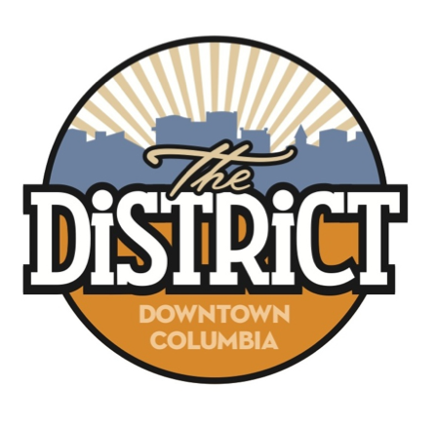

Camera Grant Program
You May Be Eligible for up to $2000 Towards a Camera S System
LIMITED TIME OFFER – EXTERIOR CAMERA SYSTEM

Join the Downtown CID’s efforts to improve safety of Downtown Columbia. By taking advantage of our Camera Grant Program, you can help keep The District safe for both those visiting and working in The District.

The Downtown CID is introducing a short-term grant program to reimburse up to $2,000 of the costs associated with purchasing and installing an exterior camera system in The District.

By installing cameras your business will help provide a safer environment for customers and staff. It also can aid the Columbia Police Department if your business is willing to share access to the camera during or after an incident has occurred.

Program Parameters:
- The Camera Grant Program is offered to any business or property within the Downtown Community Improvement District.
- The Camera Grant Program is for cameras that are outside or that are pointed outside.
- The Cameras Grant is a reimbursement grant.
  - Up to $2,000 per business/property owner is eligible for reimbursement.
  - The total amount allocated to all business/property owners in The District for this program shall not exceed $30,000 in fiscal year 2024.
  - Before purchasing the camera system, the attached grant application should be submitted to the Downtown Community Improvement District for approval.
- Once the camera system is installed, the business or property owner must submit invoices and receipts related to project expenses. Only payments made to outside vendors for equipment, supplies and labor will be counted as eligible costs.
- If a business is requesting a camera grant, the business is responsible for securing landlord approval, in writing, specifying the location of the camera system.
- The camera grant will be delivered to the name and address listed on the application within two weeks of the date in which all submitted invoices and receipts were received.
- Upon receipt of reimbursement check the business or property receiving award will be asked to fill out an Indemnity and Hold Harmless Agreement with The District.

Funds for the Camera Grant Program are limited. This program will expire September 30, 2024, or when funds have been exhausted.

Camera Grant Application

Property Owner/Business: ______________________________________________________________

Address: _____________________________________________________________________________________

Contact Name: ______________________________________________________________________________

Contact Phone Number: __________________________________________________________________

Contact E-Mail: _____________________________________________________________________________

Type/Name of Camera System to be purchased: _____________________________________

_________________________________________________________________________________________________

Anticipated installation completion date: _____________________________________________

Send this form to: Downtown CID, 11 S. 10th St., Columbia, MO 65201 or e-mail to info@discoverthedistrict.com

If a business is requesting a camera grant, please attached written approval from the landlord approving the installation of outside cameras on the property.

For more information call 573-442-6816 or e-mail the info@discoverthedistrict.com

